How to Update an Azure Data Factory Oracle Linked Service (v2.0) and Re‑point Datasets via Key Vault
This guide shows, step by step, how to (1) create an Oracle linked service (v2.0) in Azure Data Factory (ADF), (2) add and manage the password in Azure Key Vault (AKV), (3) build the Oracle connection string using the standard DESCRIPTION format, (4) reference the Key Vault secret and DESCRIPTION in the linked service, (5) switch an existing dataset to use the new linked service, and (6) verify the relationship was updated. Screenshots are embedded at the relevant steps.

Create Linked Service for key vault and the Oracle password as a Secret in Azure Key Vault (AKV)
- In the manage tab of ADF create a new link service to AKV, and make sure to have given the system assigned or user assigned permissions beforehand on the AKV so it can actually access it using Entra id.
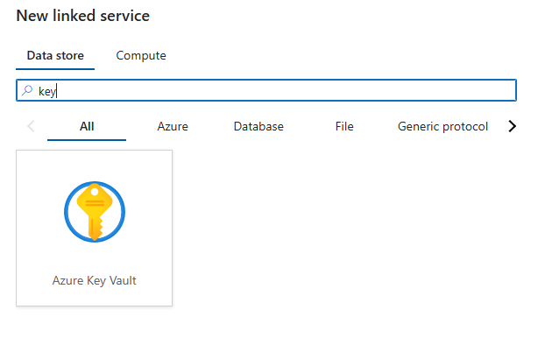
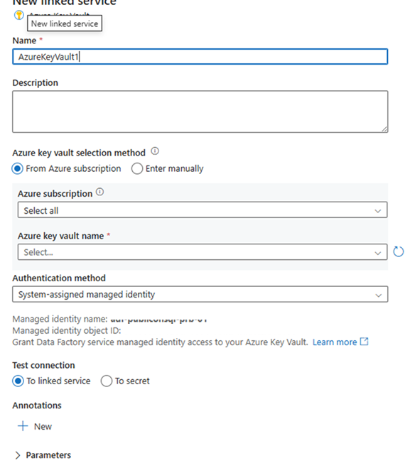

- In the Azure portal, open your Key Vault (e.g., `lskvpubliconsqlprb02`). Go to **Objects ▸ Secrets** and select **Generate/Import**.
- Create a secret named **`OraclePassword`** and set its value to the database user’s password. Save to create the first version.
Key Vault secret “OraclePassword” with versions.

1) Build the Oracle host string using the standard DESCRIPTION format
For Oracle (v2.0) in ADF, use a full DESCRIPTION string in the **Server** field. Replace placeholders with your values:
(DESCRIPTION=(ADDRESS=(PROTOCOL=tcp)(HOST=yourhost.com.co)(PORT=yourport))(CONNECT_DATA=(SERVICE_NAME=yoursname)))
• Use `SERVICE_NAME` (typical for Oracle 12c+ pluggable databases). If your database requires a SID instead, use `SID=yourSID` inside `CONNECT_DATA`.
• Keep the exact parentheses structure—ADF expects the full DESCRIPTION syntax for the Oracle 2.0 connector.
• Example: update `HOST`, `PORT`, and `SERVICE_NAME` to match your listener configuration.

2) Create the Oracle linked service (v2.0) in ADF
- In ADF, go to **Manage ▸ Linked services ▸ New** and choose **Oracle (version 2.0)**. Name the service (e.g., `lsoraclepubliconsqlprb02`) and select the correct **Integration Runtime**.
- Set **Authentication type** to **Basic**. Enter the Oracle **User name** (e.g., `testuser`). We will supply the password from Azure Key Vault in a later step.
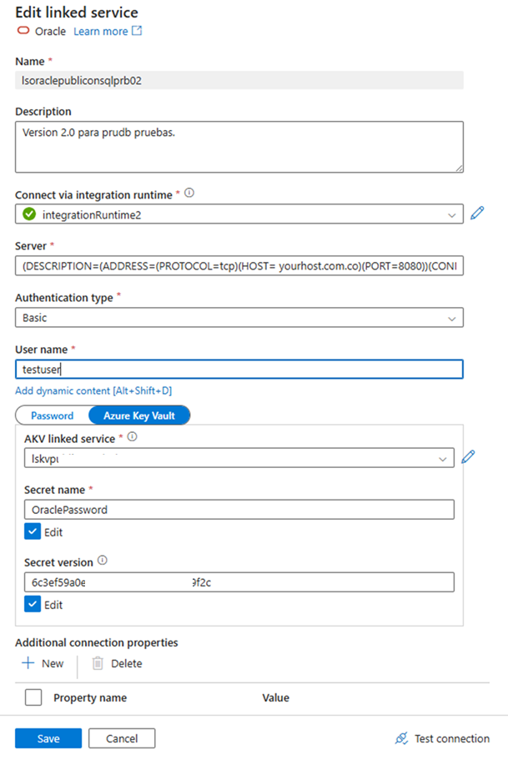
“Edit linked service” for Oracle 2.0 in ADF.

3) Reference the Key Vault secret and the DESCRIPTION host in the linked service
- Back in the **Oracle (v2.0) linked service** (Figure 1), paste your completed DESCRIPTION string into the **Server** textbox.
- Still in the linked service, switch the **Password** source to **Azure Key Vault**, choose your **AKV linked service** (e.g., `lskvpubliconsqlprb02`), and set **Secret name** to **`OraclePassword`**. Leave **Secret version** blank to always use the latest, or pin a specific version if your change-control requires it.
- Click **Test connection** to confirm connectivity, then **Create/Save** the linked service.

4) Change the relation on the existing dataset to point to the new linked service
- Open **Manage ▸ Datasets** and select your Oracle dataset (e.g., `Oratbl`). Go to the **Connection** tab.
- Switch **Linked service** to the new Oracle 2.0 linked service (e.g., `yourlinkedservice`). For the table reference, use `<OWNER>.<OBJECT_NAME>` or parameterized values (as shown below). Click **Test connection** and **Publish**.
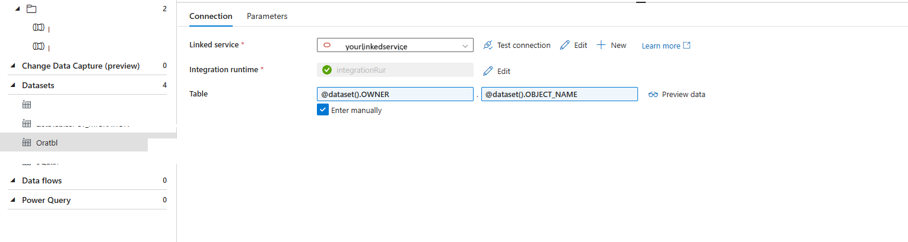
Dataset “Oratbl” now using the new linked service (parameterized OWNER.OBJECT_NAME).

5) Verify the linked relationships and that the table now uses the new connection
- In **Manage ▸ Linked services**, open the new Oracle linked service and check the **Related** tab. You should see your dataset listed (the count increases to reflect the new relation).
- Optionally, return to the dataset and click **Preview data** to confirm you can read from the target table using the new connection.
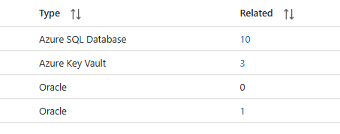
Figure 4 — “Related” view shows the Oracle linked service now associated with your dataset.

Reference
Azure Data Factory Oracle connector (v2): https://learn.microsoft.com/en-us/azure/data-factory/connector-oracle

